**Software Requirements**

**Specification**

**for**

**Twitter sentiment analysis**

## Version 1.0 approved

**30/09/2021**

***Copyright © 1999 by Karl E. Wiegers. Permission is granted to use, modify, and distribute this document.***

# Table of Contents

Table of Contents ii

Revision History ii

1. Introduction 1
   1. Purpose 1
   2. Document Conventions 1
   3. Intended Audience and Reading Suggestions 1
   4. Product Scope 1
   5. References 2
2. Overall Description 2
   1. Product Perspective 2
   2. Product Functions 2
   3. User Classes and Characteristics 3
   4. Operating Environment 3
   5. Design and Implementation Constraints 3
   6. User Documentation 3
   7. Assumptions and Dependencies 3
3. External Interface Requirements 3
   1. User Interfaces 3
   2. Hardware Interfaces 4
   3. Software Interfaces 4
   4. Communications Interfaces 4
4. System Features 4
   1. System Feature 1 4
   2. System Feature 2 (and so on) Error! Bookmark not defined.
5. Other Nonfunctional Requirements 7
   1. Performance Requirements 7
   2. Safety Requirements Error! Bookmark not defined.
   3. Security Requirements 7
   4. Software Quality Attributes 7
   5. Business Rules 8
6. Other Requirements 8

Appendix A: Glossary 8

Appendix B: Analysis Models 8

Appendix C: To Be Determined List 8

# Revision History

|  |  |  |  |
| --- | --- | --- | --- |
| **Name** | **Date** | **Reason For Changes** | **Version** |
|  |  |  |  |
|  |  |  |  |

# Introduction

## Purpose

There are already several tons of project with Twitter analysis as their base in the software development community, however there are only a handful of software that give precise and free results without signing up or without a credit card information. We wanted to enhance their functionality as well as provide it as an open-source software

## Document Conventions

API – Application Programming Interface NLP – Natural Language processing

## Intended Audience and Reading Suggestions

Primary Stakeholders – Developers, Twitter Developers – They work directly on the project.

Twitter – They provide us with the Twitter API and endpoints for accessing information on twitter

Secondary Stakeholders - End Users, Government

End users – They are our target audience. They can also be involved for user testing, design and functionality improvement.

Government – It can take insights from the data we provide to take on people opinion on a decision. Also, Government implies Guidelines and Terms of services, which the project should abide and follow.

## Product Scope

Twitter is a trending and a formal social media that provide quality content rather than entertainment. The analysis of the current situation and how people feel about a decision or a proposal is a crucial information for media and government to notice. Such a tool should be available for everyone to be aware of current affairs. Therefore, we wanted to take a step forward and provide it as an open-source software that anyone can use.

## References

* + 1. **Twitter API documentation - <https://developer.twitter.com/en/docs/twitter-api>**
    2. **Python NLP documentation - <https://www.nltk.org/>**
    3. **Numpy - <https://numpy.org/>**
    4. **Pandas – <https://pandas.pydata.org/>**
    5. **Django - <https://www.djangoproject.com/>**

# Overall Description

## Product Perspective

Twitter is a trending and a formal social media that provide quality content rather than entertainment. The analysis of the current situation and how people feel about a decision or a proposal is a crucial information for media and government to notice. Such a tool should be available for everyone to be aware of current affairs. Therefore, we wanted to take a step forward and provide it as an open-source software that anyone can use.

## Product Functions

* + 1. **Tweet Count**
    2. **Sentiment analysis**
    3. **Hashtag analysis**
    4. **Interest analysis**
    5. **Targeted Advertisement**

## User Classes and Characteristics

<Identify the various user classes that you anticipate will use this product. User classes may be differentiated based on frequency of use, subset of product functions used, technical expertise, security or privilege levels, educational level, or experience. Describe the pertinent characteristics of each user class. Certain requirements may pertain only to certain user classes. Distinguish the most important user classes for this product from those who are less important to satisfy.>

## Operating Environment

* *Twitter API key Any web browser*
* *Python and Machine learning libraries*
* *Django web server*

## Design and Implementation Constraints

No design constraints.

Implementation constraint include Security and privacy policies.

## User Documentation

<List the user documentation components (such as user manuals, on-line help, and tutorials) that will be delivered along with the software. Identify any known user documentation delivery formats or standards.>

## Assumptions and Dependencies

It is assumed that the user has internet and a good web browser.

# External Interface Requirements

## User Interfaces

<Describe the logical characteristics of each interface between the software product and the users. This may include sample screen images, any GUI standards or product family style guides that are to be followed, screen layout constraints, standard buttons and functions (e.g., help) that will appear on every screen, keyboard shortcuts, error message display standards, and so on. Define the software components for which a user interface is needed. Details of the user interface design should be documented in a separate user interface specification.>

## Hardware Interfaces

<Describe the logical and physical characteristics of each interface between the software product and the hardware components of the system. This may include the supported device types, the nature of the data and control interactions between the software and the hardware, and communication protocols to be used.>

## Software Interfaces

<Describe the connections between this product and other specific software components (name and version), including databases, operating systems, tools, libraries, and integrated commercial components. Identify the data items or messages coming into the system and going out and describe the purpose of each. Describe the services needed and the nature of communications. Refer to documents that describe detailed application programming interface protocols. Identify data that will be shared across software components. If the data sharing mechanism must be implemented in a specific way (for example, use of a global data area in a multitasking operating system), specify this as an implementation constraint.>

## Communications Interfaces

<Describe the requirements associated with any communications functions required by this product, including e-mail, web browser, network server communications protocols, electronic forms, and so on. Define any pertinent message formatting. Identify any communication standards that will be used, such as FTP or HTTP. Specify any communication security or encryption issues, data transfer rates, and synchronization mechanisms.>

# System Features

<This template illustrates organizing the functional requirements for the product by system features, the major services provided by the product. You may prefer to organize this section by use case, mode of operation, user class, object class, functional hierarchy, or combinations of these, whatever makes the most logical sense for your product.>

## System Feature 1

Tweet count

* + 1. Description and Priority

Given a topic or hashtag, the total number of tweets regarding that topic or hashtag on the twitter handle is displayed as output.

* + 1. Stimulus/Response Sequences

<List the sequences of user actions and system responses that stimulate the behavior defined for this feature. These will correspond to the dialog elements associated with use cases.>

* + 1. Functional Requirements

REQ-1.1: Click on the input form text area.

I/P: “Input” option.

O/P: user is requested to enter the keyword.

REQ-1.2: Provide a keyword for searching count of tweets. I/P: keywords

O/P: Total tweets related to keywords per hour, for the last 7 days are displayed Processing: API request is sent to the Twitter server as query and the response is

received, processed to proper format.

## System Feature 2

Analysis of the Tweets on a Hashtag

* + 1. Description and Priority
       1. Link to the top 5 post’s user's account on a topic.
       2. Recent tweets with high retweets and like.
       3. Download information as xlsx Document
    2. Stimulus/Response Sequences

<List the sequences of user actions and system responses that stimulate the behavior defined for this feature. These will correspond to the dialog elements associated with use cases.>

* + 1. Functional Requirements

REQ-2.1: Click on the “Analysis” button. I/P: “Analysis” option.

O/P: Table of the top 5 user’s account, their tweets, likes, retweets.

Processing: The keywords from the user is used as a query to send an API request to twitter’s server, all the tweets are received and filtered, sorted with respect to retweets, likes.

REQ-2.2: Click on the “Download” button I/P: “Download” option.

O/P: The content of the table is received by the user in excel format.

Processing: The content of the table which is in excel format is fetched from database and sent to user through download option.

## System Feature 3

User sentiment Analysis

* + 1. Description and Priority

Sentiment of the tweets categorized as positive, negative, neutral are provided to the user to better understand about the keyword.

* + 1. Stimulus/Response Sequences

<List the sequences of user actions and system responses that stimulate the behavior defined for this feature. These will correspond to the dialog elements associated with use cases.>

* + 1. Functional Requirements

REQ-3.1: Click on the “Sentiment” button I/P: “Sentiment” option.

O/P: Sentiment analysis on the given keyword based on categories Positive, Negative, Neutral.

Processing: The tweets related to keywords is fetched and processed using NLP to find the sentiment of the different tweets.

## System Feature 4

Find interest of a person.

* + 1. Description and Priority

Given a person’s user id, the user’s interested domain or topic is displayed.

* + 1. Stimulus/Response Sequences

<List the sequences of user actions and system responses that stimulate the behavior defined for this feature. These will correspond to the dialog elements associated with use cases.>

* + 1. Functional Requirements

REQ-1.1: Click on the input form text area. I/P: “Input” option.

O/P: user is requested to enter any user id.

REQ-1.2: Provide the user id for searching count of tweets. I/P: user id

O/P: Interested domain of the user.

Processing: The given user id is used to retrieve a list of tweets that a user has liked and those tweets are processed using NLP to find the interest if the user.

## System Feature 5

Targeted Advertisement by Businesses

* + 1. Description and Priority

Targeted advertisement for business based on an information about the users who liked a tweet posted by the business executive.

* + 1. Stimulus/Response Sequences

<List the sequences of user actions and system responses that stimulate the behavior defined for this feature. These will correspond to the dialog elements associated with use cases.>

* + 1. Functional Requirements

REQ-1.1: Click on the input form text area. I/P: “Input” option.

O/P: user is requested to enter the tweet id.

REQ-1.2: Provided the tweet id, users who liked the tweet will be displayed. I/P: Tweet id

O/P: Users who liked the tweet.

Processing: API request is sent to the Twitter server as query and the users who liked that tweet is received, processed to proper format.

# Other Nonfunctional Requirements

## Product Requirement

* + 1. **Performance Requirements:**

REQ 5.1.1.1: Execution time

Description: The processing time should not exceed 30 seconds I/P: Any query processing in the software.

O/P: Results less than 30 seconds.

## External requirements

* + 1. **Security Requirements:**

REQ 5.2.1.1: Privacy

Description: Any user or tweet related details of a private account is not collected in any way affecting the user’s privacy.

I/P: User information.

O/P: Privacy is maintained.

Processing: No data is collected from a private user.

## Software Quality Attributes

<Specify any additional quality characteristics for the product that will be important to either the customers or the developers. Some to consider are: adaptability, availability, correctness, flexibility, interoperability, maintainability, portability, reliability, reusability, robustness, testability, and usability. Write these to be specific, quantitative, and verifiable when possible. At the least, clarify the relative preferences for various attributes, such as ease of use over ease of learning.>

## Business Rules

<List any operating principles about the product, such as which individuals or roles can perform which functions under specific circumstances. These are not functional requirements in themselves, but they may imply certain functional requirements to enforce the rules.>

# Other Requirements

<Define any other requirements not covered elsewhere in the SRS. This might include database requirements, internationalization requirements, legal requirements, reuse objectives for the project, and so on. Add any new sections that are pertinent to the project.>

# Appendix A: Glossary

<Define all the terms necessary to properly interpret the SRS, including acronyms and abbreviations. You may wish to build a separate glossary that spans multiple projects or the entire organization, and just include terms specific to a single project in each SRS.>

# Appendix B: Analysis Models

<Optionally, include any pertinent analysis models, such as data flow diagrams, class diagrams, state-transition diagrams, or entity-relationship diagrams.>

# Appendix C: To Be Determined List

<Collect a numbered list of the TBD (to be determined) references that remain in the SRS so they can be tracked to closure.>

1. Prepare the E-R diagram for your project. [Show the different types of attributes such as Composite, Derived etc. and also Display the primary and foreign keys in the diagram]

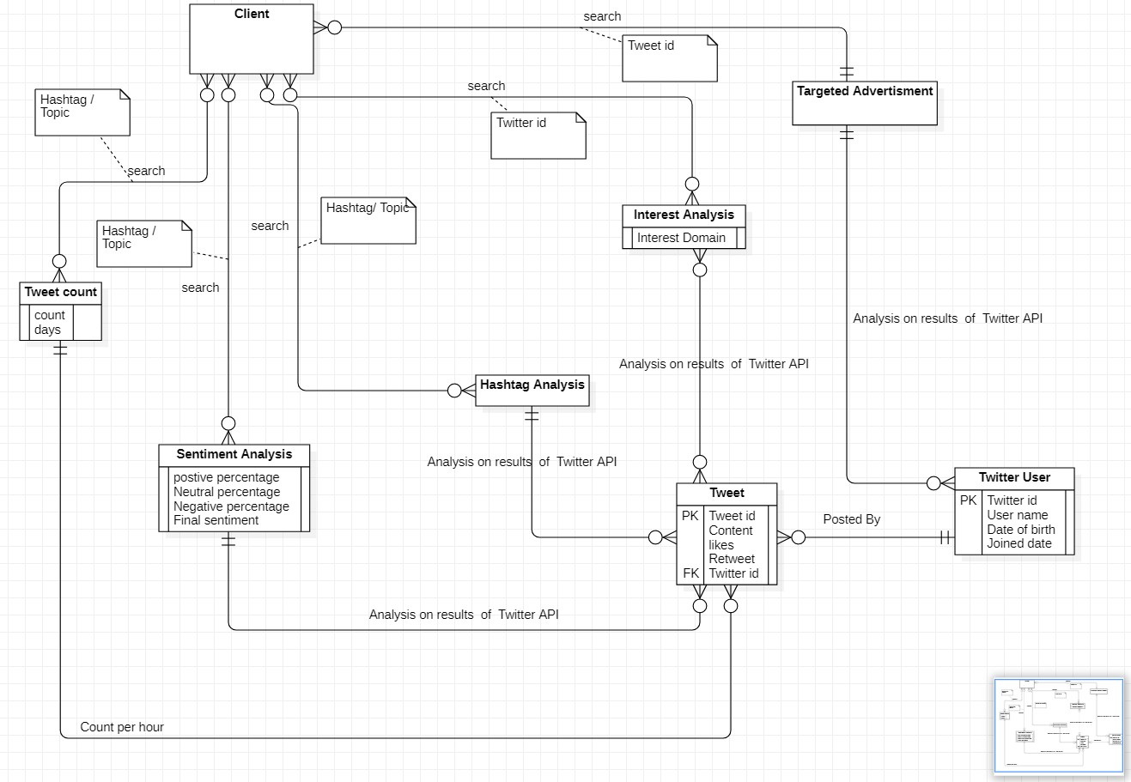

1. Draw the DFD (Context diagram (Level 0), Level 1 and Level 2)

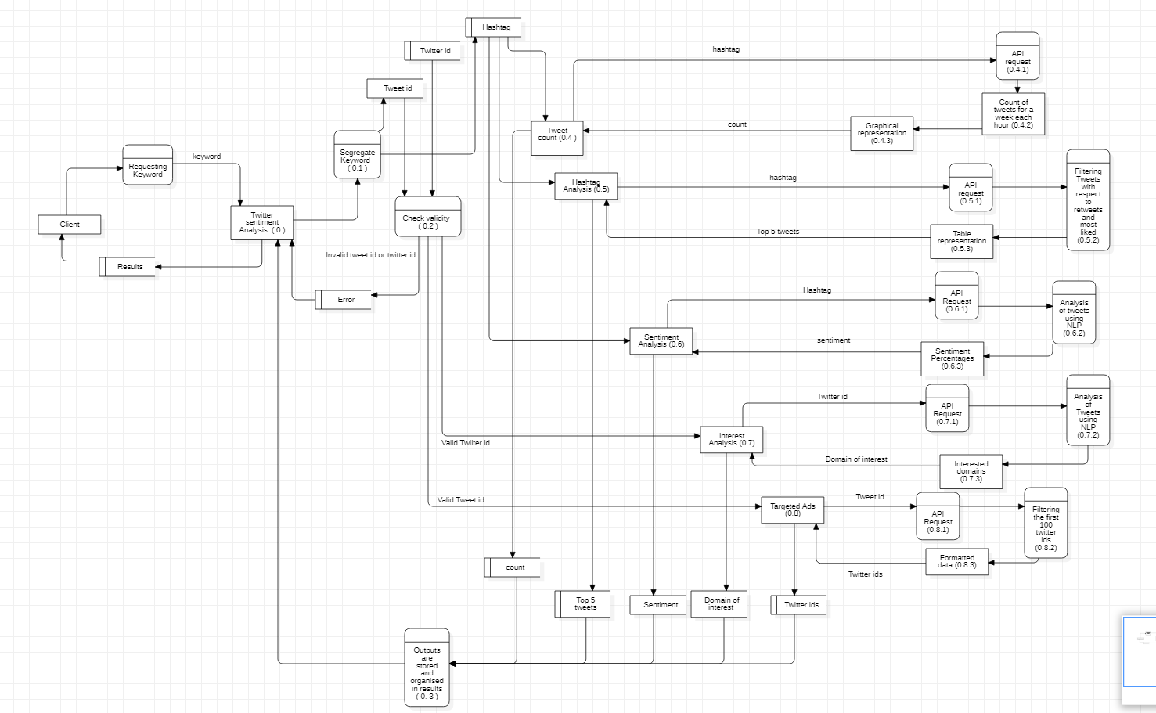

**L0**

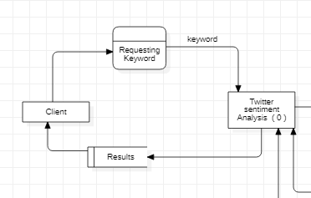

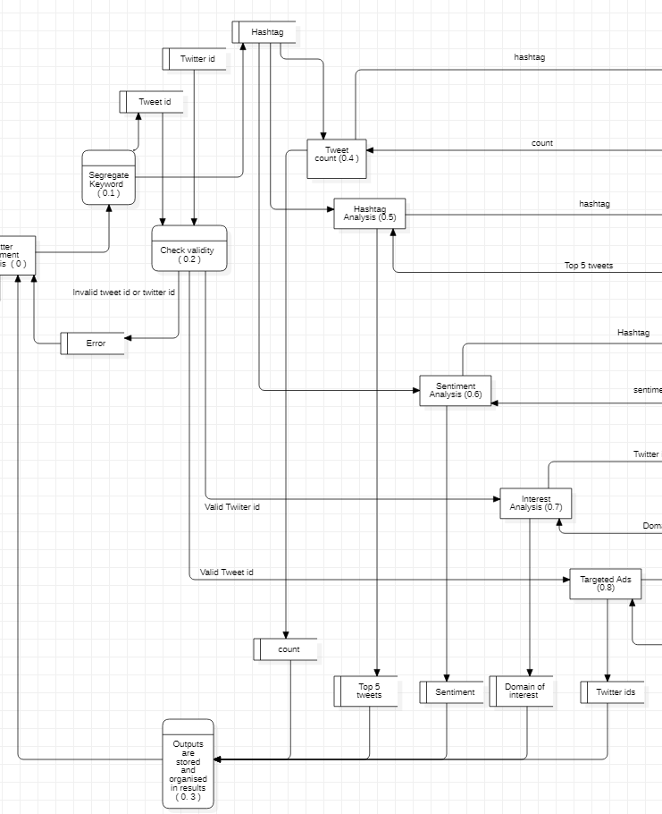

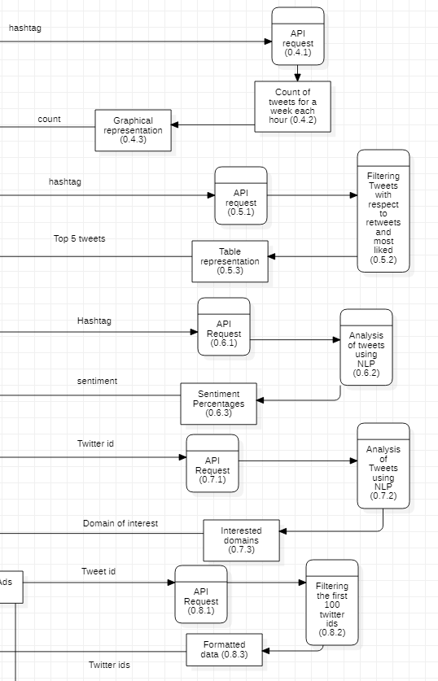

1. Prepare the Data dictionary based on the DFD.

**DATA DICTIONARY:-**

**TWITTER USER : Twitter id + User name + Date of birth + Joined date**

Twitter id: Integer User name: String Date of birth: Integer Joined date: Integer

### TWEET : Twitter id+ Content +Likes +Retweet

Twitter id: Integer Content: String Likes: Integer Retweet: String

### TWEET COUNT : [Count days , Hashtags]

Count days: integer Hashtag: String

### HASHTAG ANALYSIS : [{Tweet}*5,Hashtag]

Hashtag: String

### SENTIMENT ANALYSIS : Positive percentage+ Neutral Percentage + Negative Percentage + Final Sentiment

Positive percentage: Float Neutral Percentage: Float Negative Percentage: Float Final Sentiment: String

### INTEREST ANALYSIS : [Twitter id , Domain Of Interest]

Twitter id: Integer Domain of Interest: String

### TARGETED ADVERTISEMENT : [Twitter id , User name]

Twitter id: Integer User name: String

**Result: [**String , Table, Integer ]

**ERROR** : String